5.5 Surface Integrals Worksheet

- Evaluate , where is the portion of the plane in the first octant.
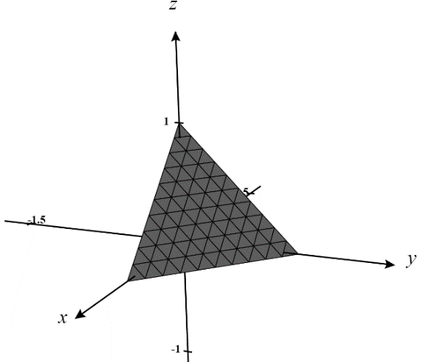
Since represents the graph of a function of the form , specifically , we do not have to find a parameterization for and instead we tackle the problem as follows.

The region D is the projection of the solid into the xy-plane as shown in the picture to the right.
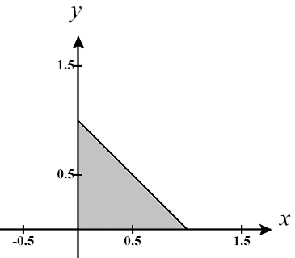
Therefore, we have that:

- Evaluate , where is the portion of the paraboloid inside the cylinder .
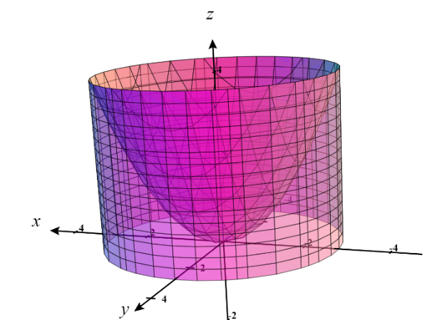
Since represents the graph of a function of the form , specifically , we do not have to find a parameterization for and instead we tackle the problem as follows.
.

The region D is the projection of the solid into the xy-plane as shown in the picture to the right.
We can view D in polar coordinates to make it easier to integrate over.
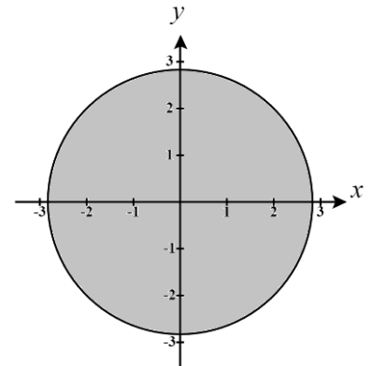
Therefore, we have that:

Let which implies . The bounds become and .
Therefore, we have

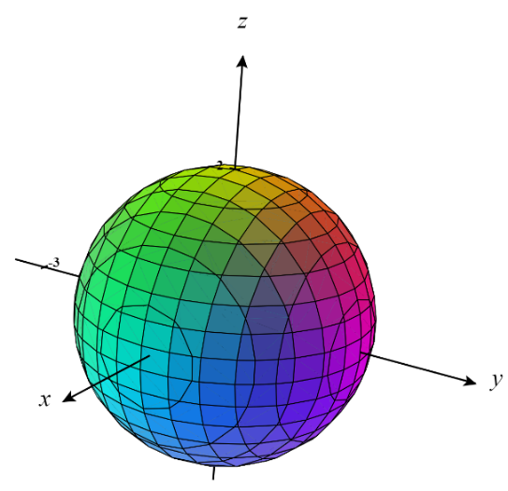
- Evaluate over the sphere .
We see that we cannot write this surface as a function and therefore we must approach this question by viewing the surface parametrically.

Parametric equations for are: , , where and a vector equation which yields is where

In order to set up the surface integral as an iterated integral we need to know . So, we calculate that

Then,

Since we know that , we have that .

Now, we have that

let , then we note that , , and . This means
- Consider the object which has the shape of the spiral ramp communicated as a parametric surface by , where and . Suppose that the density of the surface at a point is given by the function . Determine the mass of the object.
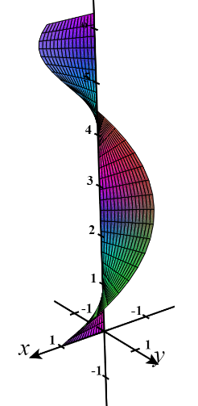
We calculate that:
Therefore,
and thus,

Now, we have that,

Evaluating this integral will require a trigonometric substitution.
Let and where . Our bounds become:
We then get that
Therefore, we get that

- Let be the surface of the solid created by the cone below the plane .
- Use a surface integral to compute the surface area of without converting the surface to a parametric form.

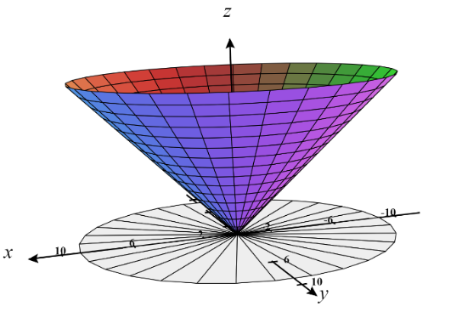

The region D is the projection of the solid into the xy-plane as shown in the picture to the right.
We can view D in polar coordinates to make it easier to integrate over.
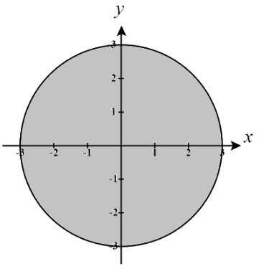
Therefore, we have that:

- Parameterize the surface .

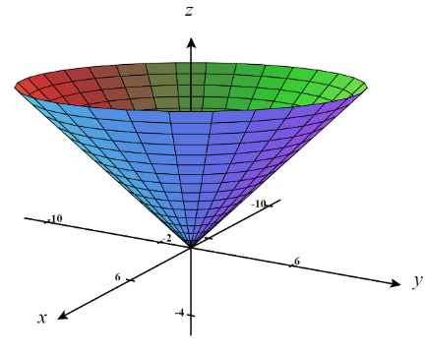
We see that as we progress up the z-axis we get circles of increasing radius. Therefore, we expect that z must vary freely while the values of x and y must create circles.
Therefore, we write create where .
(We can check with the 3D plotter to see that our parametric surface is indeed the cone we have from the beginning of the question.)

- Use a surface integral to compute the surface area using the parameterization you found in part (b).

We calculate that:
Therefore,
and thus,

Now, we have that,
- Determine the surface area for the portion of the paraboloid that sits above the xy-plane.

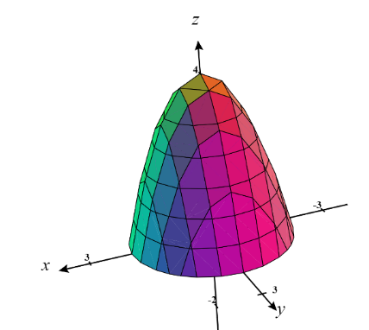
Since represents the graph of a function of the form we do not have to find a parameterization for and instead we tackle the problem as follows.
.
The region D is the projection of the solid into the xy-plane as shown in the picture to the right.
We can view D in polar coordinates to make it easier to integrate over.
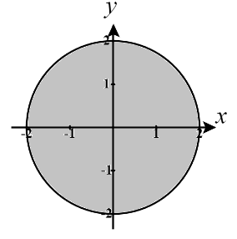
Therefore, we have that:

Let which implies . The bounds become and . Therefore, we have

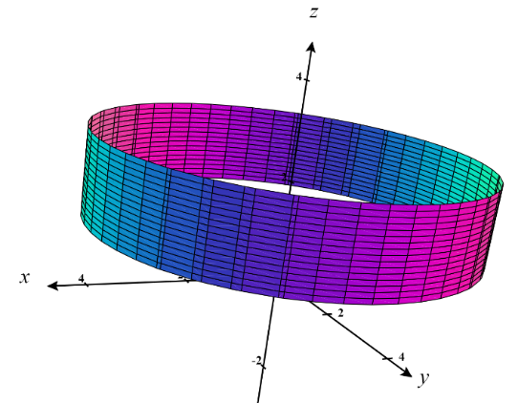
- Consider the cylindrical surface created by between the planes . Suppose that the density of the surface at a point is given by the function . Determine the mass of the object.

We see that we cannot write this surface as a function and therefore we must approach this question by viewing the surface parametrically.

We first parametrize the surface as where .
We calculate that:
Therefore,
and thus,

Now, we have that,

Evaluating this integral will require integration by parts.
Let and . This implies that and .
Therefore, by IPB, we have that:

Therefore, we get that

